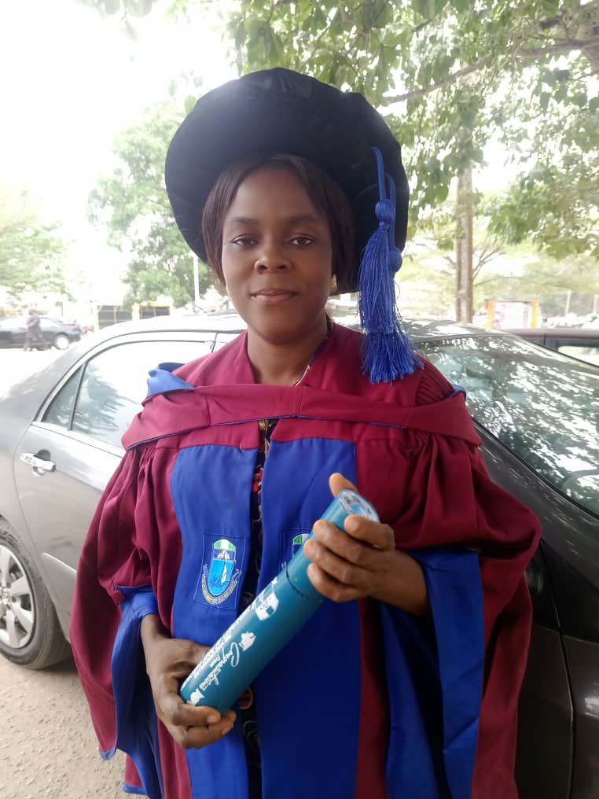
Dr. Joy Tochukwu Nnodi
Lecturer | Researcher in Artificial Intelligence and Cybersecurity
@ Federal University Otuoke, Nigeria
📧 nnodi.joy@gmail.com | nnodijt@fuotuoke.edu.ng | ☎ +2348064369582
Profile
Dr. Joy Tochukwu Nnodi is a Computer Science lecturer and researcher with over ten years of experience in academia and ICT. She holds a Ph.D. in Computer Science from the University of Port Harcourt and specializes in Artificial Intelligence, Cybersecurity, and Machine Learning applications. Her research focuses on developing intelligent systems for insider threat detection, sustainable environmental management, and predictive analytics. Dr. Nnodi is passionate about using AI to solve real-world problems and empower students through innovative, technology-driven education.
Education & Certifications
- Ph.D. (Computer Science) – University of Port Harcourt, 2023
- M.Sc. (Computer Science) – University of Port Harcourt, 2011
- B.Sc. (Computer Science) – Nnamdi Azikiwe University, 2004
- Certificate in Cybersecurity Management – Charles Sturt University, 2024
- AI for Teaching, Research & Community Service – VICBHE, 2024
Research Interests
Artificial Intelligence • Cybersecurity • Threat Detection •
Machine Learning • Sustainable Digital Transformation
Professional Memberships
- Nigeria Computer Society (NCS)
- Association of Cybersecurity Professionals
- Nigerian Women in Information Technology (NIWIIT)
Awards & Interests
Best Graduating Student, VICBHE (2024)
Reading | Research | Teaching | Traveling

